# **CVI620 – Assignment 1**

Winter 2025

| Total Mark: | 10 marks (10% of the total course grade) |
| --- | --- |
| Submission file(s): | * Assignment1.py or Assignment1.ipynb * Assignment1.docx (this document with your answers) |

Please work in **groups** of **up to** two people (can do individually as well) to complete this assignment. (**only one team member should submit).** This Assignment is worth 10% of the total course grade and will be evaluated through your submission, as well as the assignment **in-class demo**. During the lab demo, group members are randomly selected to explain the submitted solution. Group members who are not present during the assignment demo will lose the demo mark. (6% submission, 4% demo per question). The demo date is **February 11th, 2025**.

If you are unable to attend the in-class demo session for any legit reason, please provide documentation explaining your absence (e.g., an appointment confirmation or a work letter). Additionally, if you are uncomfortable with presenting, ensure that a team member is available to present on your behalf and let me know by email in advance (should attend the class anyways).

Please submit the submission file(s) through Learn@Seneca. ALL team members must submit the FINAL work. Also, make sure to provide the link to your GitHub account for all your contributions in the box below:

|  |  |
| --- | --- |
| Project GitHub repository: |  |

**Please paste the resulting images and answers in this document.**

## **Part I: A photo booth application**

For this lab, you need a webcam, or a digital camera connected and installed on your machine.

Write code to capture and show the video stream from your webcam (or camera).

* Save the snapshot. Use image names such as ‘image1.jpg’, ‘image2.jpg’, etc., automatically incrementing the filename counter. Paste some of your snapshots here:

男人戴着耳机

AI 生成的内容可能不正确。

## **Part II: Image Arithmetic**

1. Brightness and Contrast:
2. Open a color image and display. Paste a sample here.



1. Increase the brightness by adding a constant (e.g., 150) to all color channels of the image. Display in a separate window. Paste the result here.

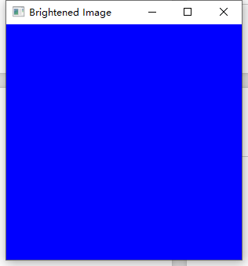

1. Change the contrast by multiplying the image by a constant (e.g., 0.5). Display in a separate window. Paste the result here.

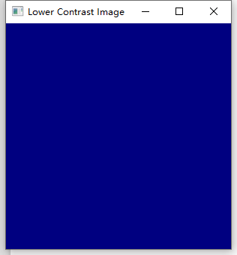

1. Linear blend:
2. Open a second images and display. Resize the second image to match the first, if needed. Paste the second image here.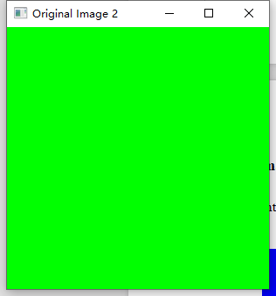
3. Ask the user for a number (alpha) between 0 and 1.



1. Implement a linear blend of the two images:

blend = (1 - alpha) * img1 + alpha * img2;

Display the result. Paste the result here.

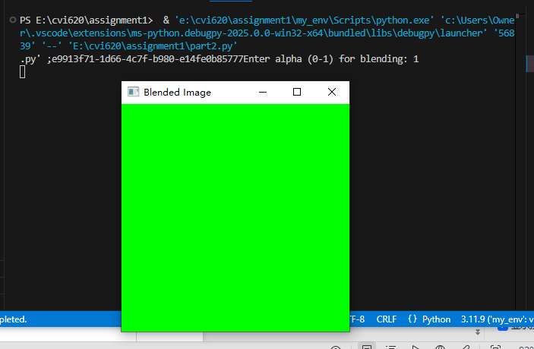

**Part III: A Drawing Application**

* 1. Create a program to draw green rectangles on a image with thickness is 4.

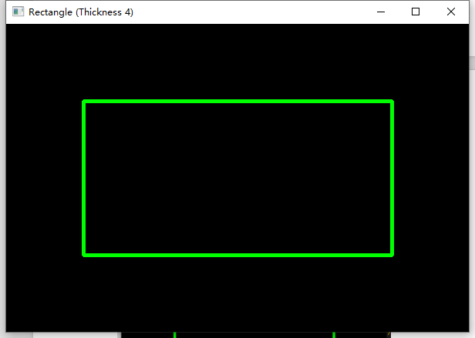

* 1. Change thickness to -1. What do you notice? Explain.

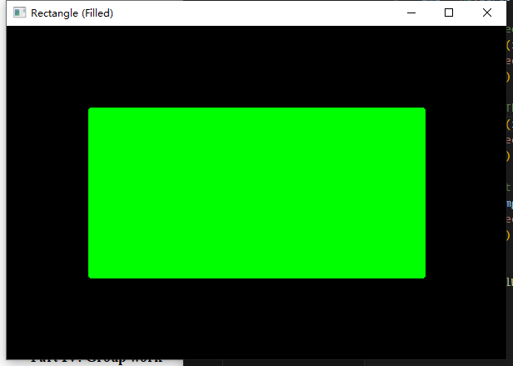

**The rectangle is getting filled.**

1.3 Create a program to put Text On the Rectangle in the Image

Display the result. Paste a sample here.

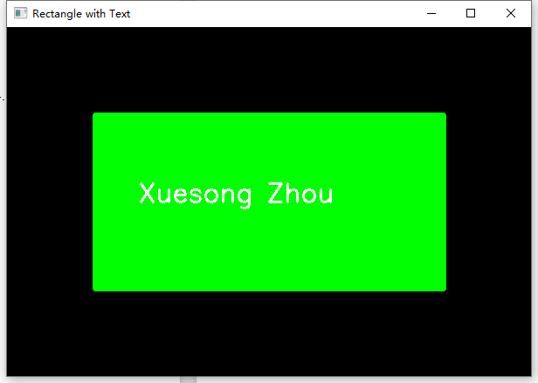

## **Part IV: Group work**

Add this declaration to your file:

We, New Group6, the only member Xuesong Zhou(mention assigned group number and your names), declare that the attached assignment is our own work in accordance with the Seneca Academic Policy. We have not copied any part of this assignment, manually or electronically, from any other source including web sites, unless specified as references. We have not distributed our work to other students.

Specify what each member has done towards the completion of this work:

|  | Name | Task(s) |
| --- | --- | --- |
| 1 | Xuesong Zhou | All tasks |
| 2 |  |  |